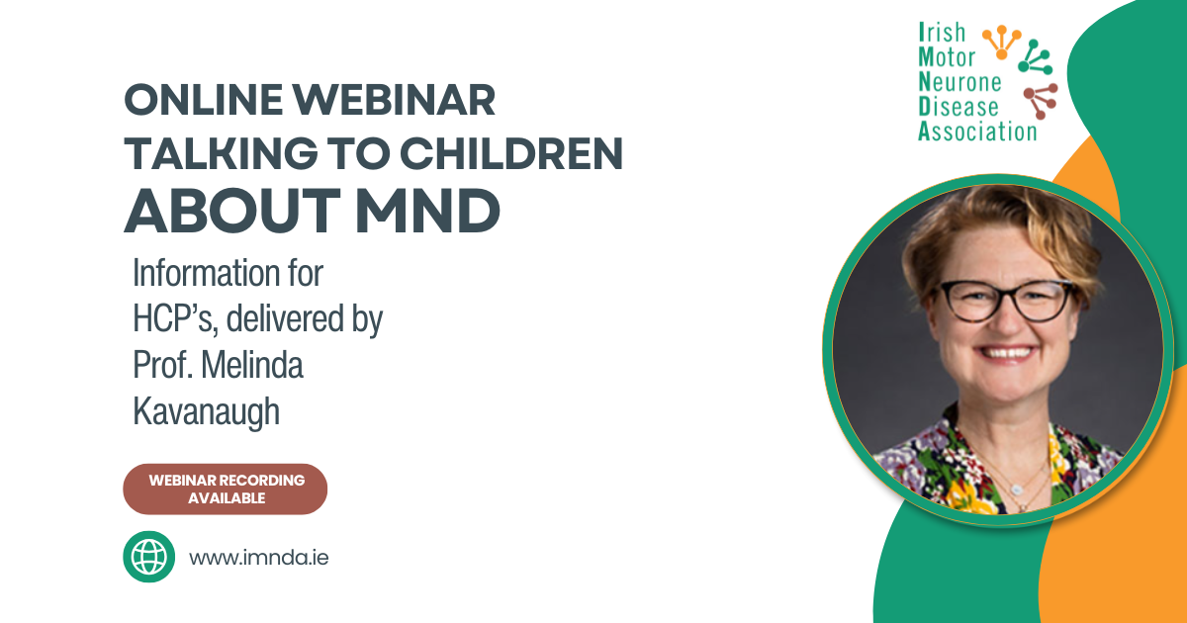

Prof Kavanaugh delivered an online education session for Healthcare Professionals on “Talking to children about MND.”
Dr. Kavanaugh is a US Professor of Social Work and a Licensed Clinical Social Worker (LCSW), with clinical expertise in health care professional education and caregiving research across neurological disorders. As well an international leader in program development, including YCare, a multidisciplinary youth caregiving skills and support protocol for young carers in ALS, cancer, Alzheimer’s disease, and spinal cord injury and traumatic brain injury in the military connected and Veteran community.
Dr. Kavanaugh’s research informed a series of books for children, young adults, families and schools including a graphic novel translated into 11 languages. She is also president of Global Neuro YCare, an international non-profit, focused on developing language and culturally accessible programs and supports for health care professionals, children, youth, and families in neurological disorders around the globe, including the animated short film, “LUKi & the Lights”, helping children and families understand and talk about ALS/MND.
Coping with a loved one having MND/ALS is tough for adults, let alone kids. It affects all people in the family – including kids. There isn’t enough information out there to help kids understand what MND/ALS is, what role kids play as caregivers, and how to talk about these issues.
To listen back to Prof Melindas talk, please click on the link here

